CSA0501-DATABASE MANAGEMENT SYSTEMS
LAB EXPERIMENTS DATE: 19-08-2026

EXPERIMENT 14 - TCL COMMANDS – COMMIT, SAVEPOINT, ROLLBACK

AIM:

To learn how to use various TCL commands Commit, Savepoint and Rollback SQL commands.

PROCEDURE:
- Display the existing records in the INTERN table.
- Update an existing intern record.
- Create SAVEPOINT A.
- Insert a new intern record.
- Create SAVEPOINT B.
- Insert another intern record.
- Create SAVEPOINT C.
- Roll back to SAVEPOINT B.
- Display the records and verify that the changes after SAVEPOINT B are removed.
- Use COMMIT to permanently save the required changes.

PROGRAM 1:

START TRANSACTION;

INSERT INTO INTERN
(InternID, InternName, Domain, Age, Email, FacNo)
VALUES
(501, 'Anu', 'Python Developer', 20, 'anu@gmail.com', 201);

SAVEPOINT A;

OUTPUT:
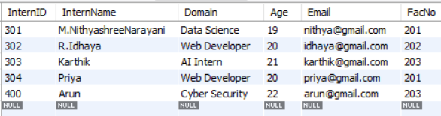

INSERT INTO INTERN

(InternID, InternName, Domain, Age, Email, FacNo)

VALUES

(401, 'Priya', 'Web Development', 20, 'priya@gmail.com', 201);

SAVEPOINT B;

SELECT * FROM INTERN;

OUTPUT:
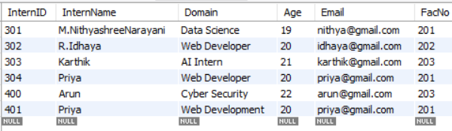

INSERT INTO INTERN
(InternID, InternName, Domain, Age, Email, FacNo)
VALUES
(402, 'Rahul', 'Data Analytics', 21, 'rahul@gmail.com', 202);

SAVEPOINT C;

SELECT * FROM INTERN;

INSERT INTO INTERN
(InternID, InternName, Domain, Age, Email, FacNo)
VALUES
(503, 'Rahul', 'Data Analytics', 22, 'rahul@gmail.com', 203);

SAVEPOINT C;

SELECT * FROM INTERN;

ROLLBACK TO B;

SELECT * FROM INTERN;

COMMIT;

OUTPUT:
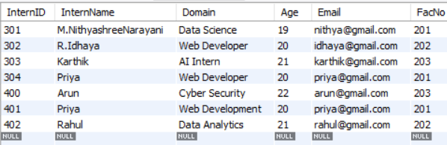

RESULT:
Thus, the TCL commands COMMIT, SAVEPOINT, and ROLLBACK were successfully performed on the INTERN table. The transaction was rolled back to the specified savepoint and the required changes were permanently saved using COMMIT.

